**ENV & ARG Directive/instruction**

* The ENV directive is used to set environmental variables.
* These environmental variables are used by applications to get information
* Syntax

ENV <key> <value>

* ARG instruction is used to define the variables that the user can pass while building the image
* Syntax

ARG <variablename>=<defaultvalue>

* ENV variables will be available in the containers also
* Changeset containing the Dockerfile(Link: https://github.com/asquarezone/DockerZone/commit/378a60d4146ee1a2e6ec022ba20bdddf4dfa9da0)
* Now while building the images using docker file use the following commands and explore the differences

docker image build -t envargdemo:1.0 --build-arg downloadlocation='https://referenceappkhaja.s3-us-west-2.amazonaws.com/spring-petclinic-2.2.0.BUILD-SNAPSHOT.jar' .

# login into the container to see the file downloaded and the environmental variables

docker container run -it envargdemo:1.0 /bin/bash

ls

echo $dummy

echo $applicationpath

exit

# Create one more container

docker container run -e dummy='test' -it envargdemo:1.0 /bin/bash

ls

echo $dummy

echo $applicationpath

exit

**WORKDIR instruction**

* In the below image we ran two different containers where the working directory of the containers are different 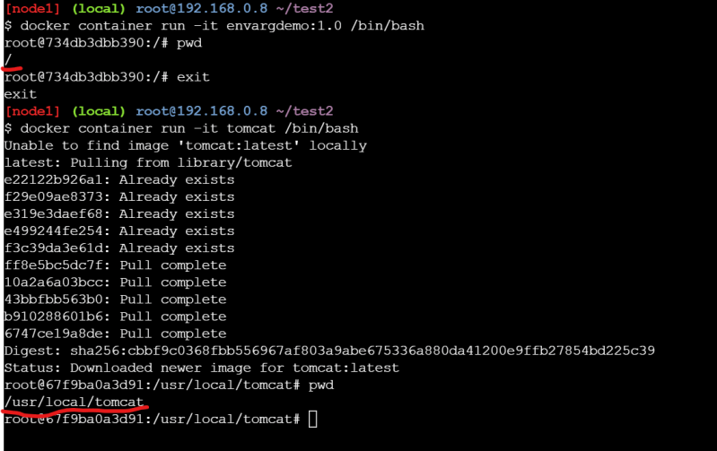
* By default if we donot specify the default working directory is /
* Where as in Dockerfile it is possible to change the working directory
* Ref:(https://github.com/asquarezone/DockerZone/commit/9d58075d9d97b8cade58197bf9c1fce026cb1ab5?branch=9d58075d9d97b8cade58197bf9c1fce026cb1ab5&diff=split)for the changeset 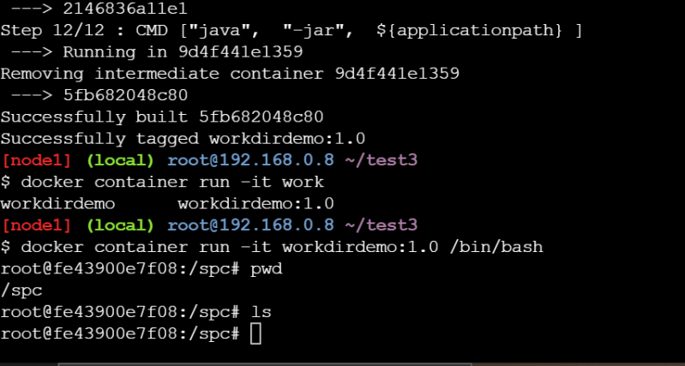

**ADD and COPY instruction**

During the docker image build process we might require to copy files from our local system into docker image filesystem. This can be acheived by using COPY/ADD instruction

COPY <source> <destination>

ADD <source> <destination>

* In some cases while building docker image you might require to download the files from some urls and copy to the docker file system, then we can use ADD instruction

ADD <source> <destination>

* Ref:(https://github.com/asquarezone/DockerZone/commit/957549fb0afa8c968ddb332bfaf0a982676ba484) and try to build the docker image and check the behavior of COPY and workdir

**USER instruction**

* Look at the example below 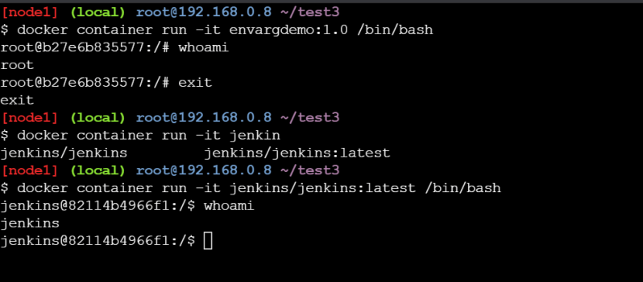
* So there is some way to set the default user other than root user in DockerImage. This can be achieved by using USER instruction